SSURGO OnDemand

[Type the document subtitle]

[Type the abstract of the document here. The abstract is typically a short summary of the contents of the document. Type the abstract of the document here. The abstract is typically a short summary of the contents of the document.]

SSURGO OnDemand

[Type the document subtitle]

# [Type sidebar title]

[Type the sidebar content. A sidebar is a standalone supplement to the main document. It is often aligned on the left or right of the page, or located at the top or bottom. Use the Drawing Tools tab to change the formatting of the sidebar text.]

Heading 1

On the Insert tab, the galleries include items that are designed to coordinate with the overall look of your document. You can use these galleries to insert tables, headers, footers, lists, cover pages, and other document building blocks. When you create pictures, charts, or diagrams, they also coordinate with your current document look.

## Heading 2

You can easily change the formatting of selected text in the document text by choosing a look for the selected text from the Quick Styles gallery on the Home tab. You can also format text directly by using the other controls on the Home tab. Most controls offer a choice of using the look from the current theme or using a format that you specify directly.

To change the overall look of your document, choose new Theme elements on the Page Layout tab. To change the looks available in the Quick Style gallery, use the Change Current Quick Style Set command. Both the Themes gallery and the Quick Styles gallery provide reset commands so that you can always restore the look of your document to the original contained in your current template.

### Heading 3

On the Insert tab, the galleries include items that are designed to coordinate with the overall look of your document. You can use these galleries to insert tables, headers, footers, lists, cover pages, and other document building blocks. When you create pictures, charts, or diagrams, they also coordinate with your current document look.

Properties

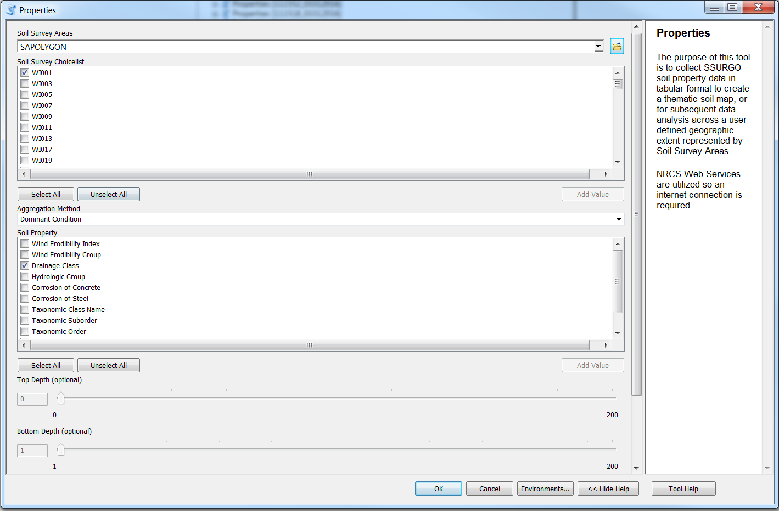

Figure : SSURGO ONDEMAND TOOL For Soil Properties

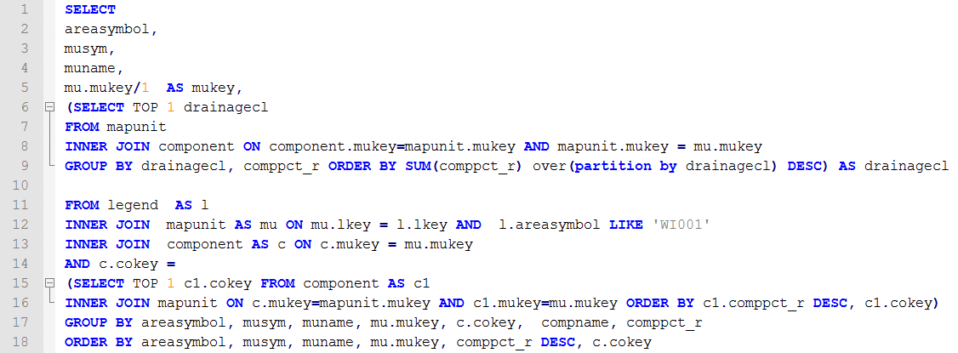

Figure : Soil Properties – Aggregation Method Dominant Condition SQL Script

* The dominant condition is done in line 6-9
* Orders by grouping the components together and then sums the component percent. The group with the higher component percent is then selected
* Lines 14-18 are basically irrelevant. It’s just grabbing one component to eliminate duplication.

Table

|  |  |  |  |  |
| --- | --- | --- | --- | --- |
| Soil Property | Definition | Dominant  Condition | Dominant  Component | Weighted Average |
| Wind Erodibility Index |  | X |  |  |
| Wind Erodibility Group |  | X |  |  |
| Drainage Class |  | X |  |  |
| Hydrologic Group |  | X |  |  |
| Corrosion of Concrete |  | X |  |  |
| Corrosion of Steel |  | X |  |  |
| Taxonomic Class Name |  | X |  |  |
| Taxonomic Order |  | X |  |  |
| Taxonomic Temp Regime |  | X |  |  |
| T-Factor |  | X |  |  |
|  |  |  |  |  |
|  |  |  |  |  |
|  |  |  |  |  |
|  |  |  |  |  |